1. Rules

You may notice on the syllabus there are four lines that are left blank (or may have already been filled in). This is place for each class to create their own classroom rules. To summarize my concept for classroom rules, I believe that if students are a part of creating their own rules, then they feel more connected to them, understand then, respect them, and ultimately follow them to have a smooth functioning! Our goal this year is to collaboratively create rules that tie into Young’s expectations of being “Responsible, Ready, and Respectful” so if I may, let me explain my little process for meeting this goal.

I value the idea that class rules are actually a part of student learning. Yes, they can indeed learn history through following rules! I am tying this concept into the topic of US government that students are expected to learn this year. Let me explain ☺

The students will take on the role of the legislative branch (Congress) - their job is to make the “laws” or rules, as we know them. My role as their teacher, is the executive branch (Ms. President, if you will) – I carry out the laws that “Congress” makes (and yes, I do have the power to veto any “unjust laws ;). Basically, I hold kids accountable and lead them in their law making decisions. I can even propose a “bill” to them if I have an idea for a class “law.” Our lovely and noble administrative team serves wonderfully as the judicial branch (Courts) – they interpret the laws that our brilliant congress creates! They are the ones, if a law is broken enough, to establish a proper consequence.

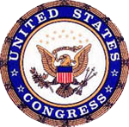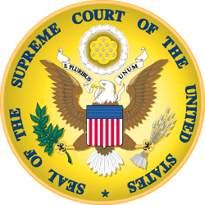

1. Positive and Negative Corrective Actions

Speaking of consequences, let me explain how the “executive” and “judicial” branch are working together to keep students on the right track and be “law abiding citizens.” In my classroom, when a student does something glowing wonderful such as demonstrating great collaboration, creativity, critical thinking, leadership, kindness, motivation, ect., they are awarded with Dojo Points. Students can accumulate these points to choose between a variety of rewards such as Class DJ (gets to play music for the class that day), extra “money” on their class check (which they can “cash” for bathroom passes, homework passes, supplies, and points on quizzes/tests), ability to swap seats with a classmate, request a positive call home, Cozy Time (borrow a pillow and blanket for the day, bring a (non-messy) snack to class, or the change to pillage the treasure chest of mystery!! Rewards are fun and I greatly prefer doling those out over punishing students. However, sometimes we forget out class laws, so of course I’ll give students a reminder if that happens. Sometimes law breaking continues though, and in that case, I use Young’s demerit system. This system gives students consequences for their actions, keeping them accountable, all the while, keeping them in the classroom. Students can accumulate demerits to receive consequences such as parent phone calls, d-halls, ISS, ect. Using this system prevents students from continually venturing to the “courts” in the office for their verdict (although administrators are always available of course). In addition to the demerit system- I like to hold students accountable by having them complete “behavior improvement forms,” that may put their behavior into a different perspective.

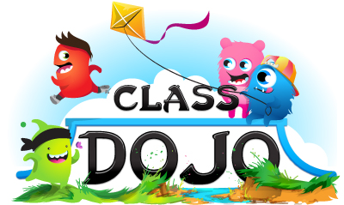

1. Grading

So now that I have extensively covered students behavior, let me briefly fill you in on grading. Here is how myself- and all of the US History team- will be weighing students’ grades.

10% Professional communication and collaboration

20% Classwork/ Homework

30% Quizzes

40% Tests

Zeros are not an option in the History department. If a student does not complete an assignment, they will be assigned lunch EASE which can result in demerits and d-hall until the assignment is completed to the level the teacher deems worthy. 